Test Paper No _____

APPLECROSS SENIOR HIGH SCHOOL

3A 3B HUMAN BIOLOGICAL SCIENCE

DO NOT MARK THIS TEST PAPER IN ANY WAY

PART I

From the alternatives available choose the BEST response. Answer questions 1 to 30 on the multiple choice answer sheet provided.

___________________________________________

QUESTIONS 1 and 2 refer to Figure 1 below.

.

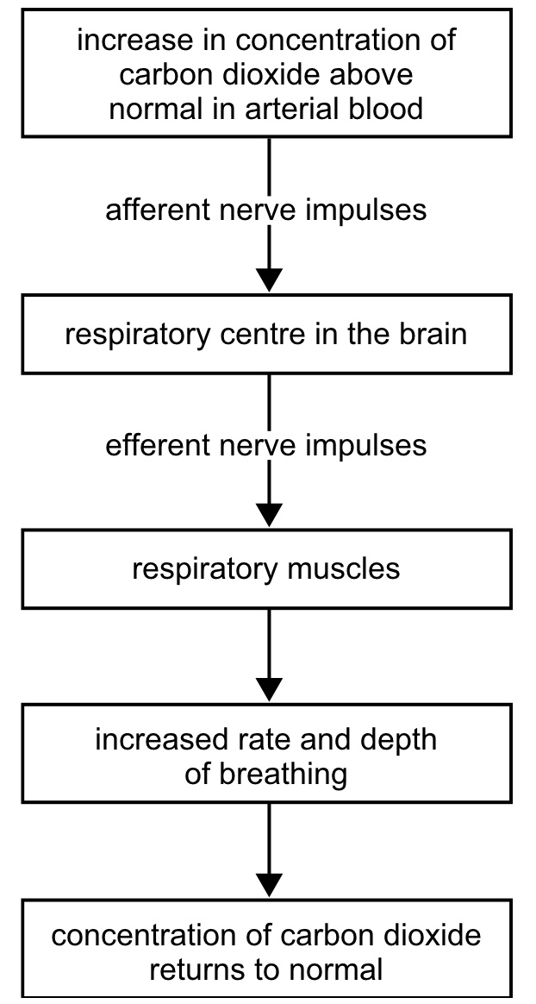

Figure 1. The regulation of carbon dioxide concentration in arterial blood.

1. The effector in the regulation of carbon dioxide concentration is the:

(a) respiratory muscles.
(b) efferent nerve impulses.
(c) respiratory centre in brain.
(d) afferent nerve impulses.
2. When the concentration of carbon dioxide returns to normal it would be reasonable to conclude that the:

(a) respiratory muscles stop contracting.
(b) rate and depth of breathing decrease.
(c) number of afferent nerve impulses increase.
(d) respiratory centre in the brain fails to send efferent nerve impulses.

3. _________________ regulates the kidney's retention of water. Its secretion is suppressed by alcohol.

(a) Prolactin
(b) Oxytocin
(c) Thyroxine
(d) Antidiuretic hormone

4. Which of the following hormones raises the blood sugar level?

(a) Glucagon
(b) Oxytocin
(c) Insulin
(d) Antidiuretic hormone

5. What is the name of the region of the brain that controls body temperature?

(a) Medulla Oblongata
(b) Hypothalamus
(c) Pituitary gland
(d) Meninges

6. Which of these causes an increase in heart rate?

(a) parasympathetic stimulation
(b) decrease in CO₂
(c) increase in pH
(d) epinephrine

7. For long-term storage, glucose is converted to ______ , while for short-term storage, glucose is converted to ______.

(a) fat, glycogen
(b) glycogen, protein
(c) pyruvic acid, fat
(d) fat, pyruvic acid

8. A good example of a positive feedback mechanism would be

(a) body temperature regulation.
(b) regulating glucose levels in the blood.
(c) enhancement of labor contractions by oxytocin.
(d) blood calcium level regulation.

9. Parathyroid hormone (PTH) controls the homeostasis of calcium in the blood. The diagram below summarizes the mechanisms controlling the secretion of PTH by the parathyroid gland.
Figure 2.

If the secretion of PTH from the parathyroid gland increased you would expect:

(a) blood calcium to increase.
(b) calcium to be deposited in the bones.
(c) calcium concentration in the urine to increase.
(d) reduced absorption of calcium in the digestive tract.

10. The diagram below illustrating the chambers of the heart and the direction of impulses through the conducting system.

Figure 3.

Which of the following is CORRECT?

(a) A is stimulated by sympathetic nerve fibres to increase heart rate.
(b) A is inhibited by sympathetic nerve fibres to increase heart rate.
(c) A is stimulated by parasympathetic nerve fibres to increase heart rate.
(d) A is inhibited by parasympathetic nerve fibres to increase heart rate.
11. Under nervous stimulation the hypothalamus secretes chemicals which trigger the production of thyroid-stimulating hormone by the pituitary. The thyroid gland is stimulated to produce hormones which in turn suppress the production of thyroid- stimulating hormone.

Which one of the following most correctly represents the above information?

(a) A.
(b) B.
(c) C.
(d) D.

12. Which one of the following can bring about the change of stored glycogen into glucose?

(a) Insulin.
(b) Adrenalin.
(c) TSH.
(d) Somatotrophic hormone.

13. The hormone glucagon is secreted by the:

(a) liver and causes conversion of glycogen to glucose in the liver.
(b) pancreas and causes conversion of glycogen to glucose in the liver.
(c) liver and causes conversion of glucose to glycogen in the liver.
(d) pancreas and causes conversion of glucose to glycogen in the liver.

14. Loss of excess heat from the body involves:

(a) vasodilation of blood vessels in the skin under control of the sympathetic nervous system.
(b) sweating under the control of the parasympathetic nervous system.
(c) the pituitary as the controlling centre.
(d) piloerection to increase surface area.

15. Which of the following responses occur when there is a fall in body temperature?

I Shivering.
II Vasoconstriction in skin.
III Decreased breathing rate.
IV Increased depth of breathing.

(a) I only.
(b) I and II only
(c) I, II and III only.
(d) I, II, III and IV.

16. The rhythmic control of breathing is produced by the activity of inspiratory and expiratory neurons located in the:

(a) Medulla Oblongata.
(b) Pons.
(c) Midbrain.
(d) Hypothalamus.

17. Which of the following statements about antidiuretic hormone (ADH) is INCORRECT?

(a) ADH causes the kidneys to remove water from glomerular filtrate and return it to the bloodstream thus decreasing urine volume.
(b) The pituitary releases ADH in response to a low water concentration in the plasma.
(c) Alcohol inhibits ADH secretion and therefore increases urine output.
(d) ADH concentration in blood remains constant to maintain homeostasis.

18. A person who lacks sufficient iodine in the diet is unable to manufacture thyroxin. This is because iodine is required by the thyroid gland to manufacture thyroxin. It is reasonable to conclude that when a person lacks sufficient iodine in the diet:

(a) TSH production would increase.
(b) TRH production would decrease.
(c) the negative feedbacks would cease to operate.
(d) the metabolic rate of cells in the body would increase.
19. If communication between the SA node and the AV node became blocked, which will most likely occur?

(a) The rate of ventricular contraction will decrease.
(b) The rate of atrial contraction will decrease.
(c) Stroke volume will increase.
(d) The rate of atrial contraction will increase.

20. Immediately after a haemorrhage, baroreceptors_________ their firing rate, signaling the medullary cardiovascular center to __________the activity of the sympathetic nerves to the heart, arterioles and veins.

The result of this reflex would be to increase the__________and____________to above normal levels and to bring the ___________,____________and ____________back toward pre-haemorrhage values.

(a) increase; increase; stroke volume, peripheral resistance; heart rate, cardiac output and arterial blood pressure.
(b) decrease; increase; heart rate, peripheral resistance; stroke volume, cardiac output and arterial blood pressure.
(c) increase; decrease; heart rate, peripheral resistance; stroke volume, cardiac output and arterial blood pressure.
(d) decrease; increase; heart rate, arterial blood pressure; peripheral resistance, stroke volume and cardiac output.

21. Which of these statements is NOT true regarding the temperature regulation function of the skin?

(a) As sweat evaporates from the skin, it carries away heat and drops body temperature.
(b) When body temperature increases, blood vessels in the epidermis dilate to transfer heat to the skin.
(c) The skin can lose heat by radiation, conduction, evaporation, or convection.
(d) If skin temperature falls below 10°C, blood vessels in the skin dilate.

22. Blood Pressure is regulated by all of the following, except:

(a) Venous return
(b) Oxygen levels
(c) Peripheral vasoconstriction
(d) Stroke volume

23. Which of the following is NOT a function of muscle?

(a) Maintaining posture
(b) Movement
(c) Generating heat
(d) Producing red blood cells

24. Actin myoﬁlaments

(a) are attached to the Z line.
(b) are found primarily in the H zone.
(c) are thicker than myosin myoﬁlaments.
(d) all of the above.

25. The basic structural and functional unit of skeletal muscle is the

(a) ﬁbre
(b) fascicule
(c) myoﬁbril
(d) sarcomere

26. When a person moves their arm from A to B as shown in the diagram below:
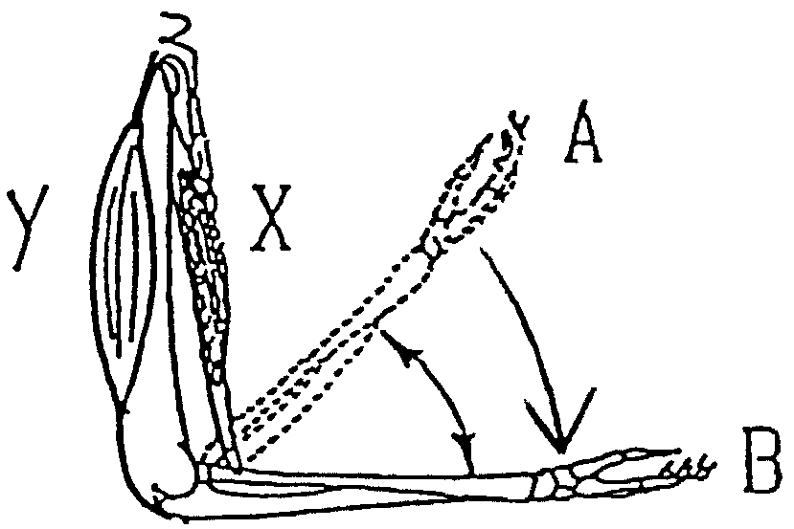
Figure 4.

(a) muscles X and Y both contract.
(b) muscle X contracts and muscle Y relaxes.
(c) muscle X relaxes and muscle Y contracts.
(d) muscle X and Y both relax.

27. Which grouping of muscle constituents is listed correctly in descending order of size?

(a) actin-myosin, myoﬁbril, myoﬁlament, muscle ﬁbre
(b) muscle ﬁbre, myoﬁbril, actin-myosin, myoﬁlament
(c) myoﬁlament, muscle fibre, actin-myosin, myoﬁbril
(d) muscle ﬁbre, myoﬁbril, myoﬁlament, actin-myosin

28. Movement at a joint away from the midline is known as _____________, and movement towards the midline is _____________.

(a) ﬂexion; extension
(b) extension; ﬂexion
(c) adduction; abduction
(d) abduction; adduction

29. Turning on a bathroom tap requires the

(a) abduction of the arm.
(b) adduction of the arm.
(c) circumduction of the arm.
(d) rotation of the arm.

30. According to the sliding ﬁlament mechanism of skeletal muscle contraction, during contraction:

(a) The thick ﬁlaments stay the same size but the thin ﬁlaments shorten.
(b) The sarcomeres shorten.
(c) The thin ﬁlaments stay the same size but the thick ﬁlaments shorten.
(d) Both thick and thin ﬁlaments shorten.

PART II

QUESTION 31 refers to Figure 5.

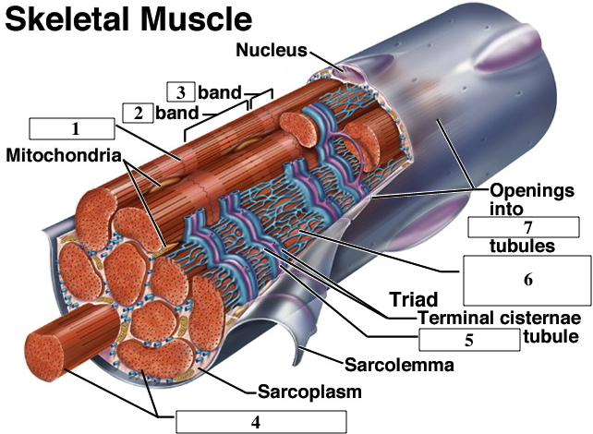

Figure 5.

31. Identify the structures of the muscle fibre indicated by the numbers 1 to 7 (Some words may be used more than once, and may require two word answers).

- __________________________________
- __________________________________
- __________________________________
- __________________________________
- __________________________________
- __________________________________
- __________________________________
(4 marks)

32. Complete the physiological aspects of the homeostatic feedback system below.
Stimulus: Increase in osmotic pressure (low levels of water in the blood plasma)
Receptor: ____________________________________________________________________
_________________________________________________________________(1)
Modulator: ____________________________________________________________________
____________________________________________________________________
_________________________________________________________________(2)
Effector: ____________________________________________________________________
_________________________________________________________________(1)
Response: ____________________________________________________________________
_________________________________________________________________(1)
Feedback: ____________________________________________________________________
_________________________________________________________________(1)
QUESTION 33 refers to Figure 6.
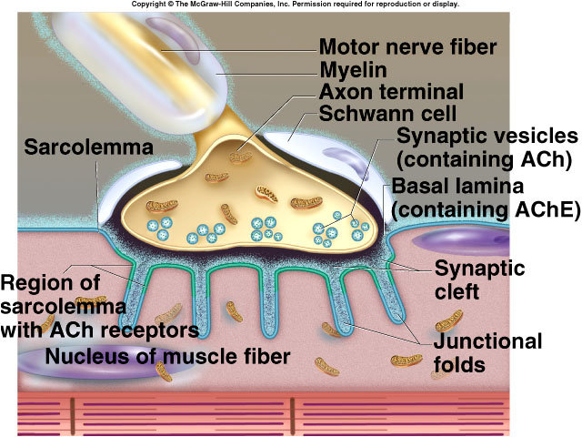
Figure 6.

33. Use the diagram above to explain what happens at a neuromuscular junction. Use appropriate terminology provided in the diagram in your response.

(5 marks)
34. Complete the table below that compares the two different forms of diabetes melitus.

Diabete melitus | Type I | Type II
Description of disorder
Causes of disorder
Treatment of disorder
(6 marks)

35. Briefly explain each stage indicated (1-4). Include the role of energy in the muscle contraction cycle.

______________________________________________________________________________________________________

________________________________________________________________________________________________________________________
________________________________________________________________________________________________________________________
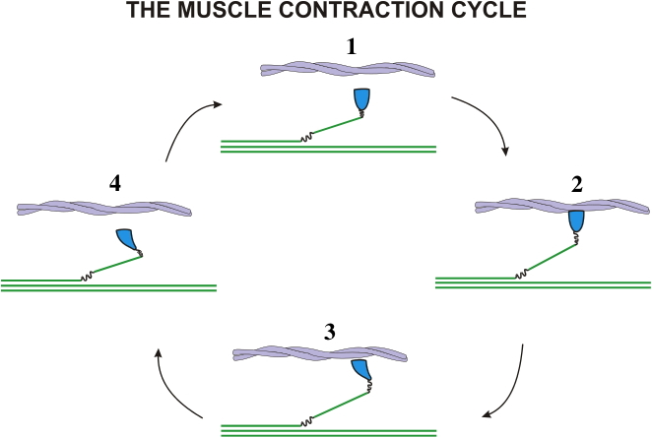
______________________________________________________________________________________________________

(4 marks)

